Integrated Group Project Journal

**Week 1** **2**

**Week 2** **2**

**Week 3** **2**

# Week 1

We began with a very simple group meeting sharing our ideas and what we thought would be the best direction to go in that would use all our strengths. We decided our project would be a web based storefront that Brighton students could use to sell goods and or services. We also discussed each other's strengths in terms of project work. We delegated basic tasks for the scope of the whole project to get a rough idea of who would be doing what during the upcoming weeks and had a vote on doing either a presentation or a report. Presentation was the chosen format. Finally we named our website Eureka, started a Trello and wrote down a list of basic requirements. The basic functions we lined out this session are as follows:

1. Login and Registration
2. Landing/Home Page
3. Product/Service Page
4. Profile Pages

# Week 2

We created a group Discord so we could all remain in contact outside of university lab sessions. This proved useful during the adverse weather conditions prohibiting us from attending on campus. We had a short meeting via Discord to discuss further what directions we needed to be going in during the upcoming weeks. The scope of the project got very large during this meeting and we reminded ourselves that the assignment is to produce a prototype not a finished product, meaning full functionality is not required. We decided to fully start delegating tasks in the next session face to face as that is easier than on a voice call.

# Week 3

Following on from our remote meeting we discussed how we'd actually begin practical work for the assignment. At this early stage it was quite a challenge to think of jobs to delegate; we disagreed over starting wireframes this early before any research. We then collectively came to the conclusion that at least a basic layout on paper would be a good start from a pre research perspective and we could use the research we undertake to steer those early designs in the right direction. We assigned two group members to undertake early wireframe designs as this would give us two different outlooks and more to work with. We then planned for two other members to undertake research in relevant web technologies and into our direct competition.

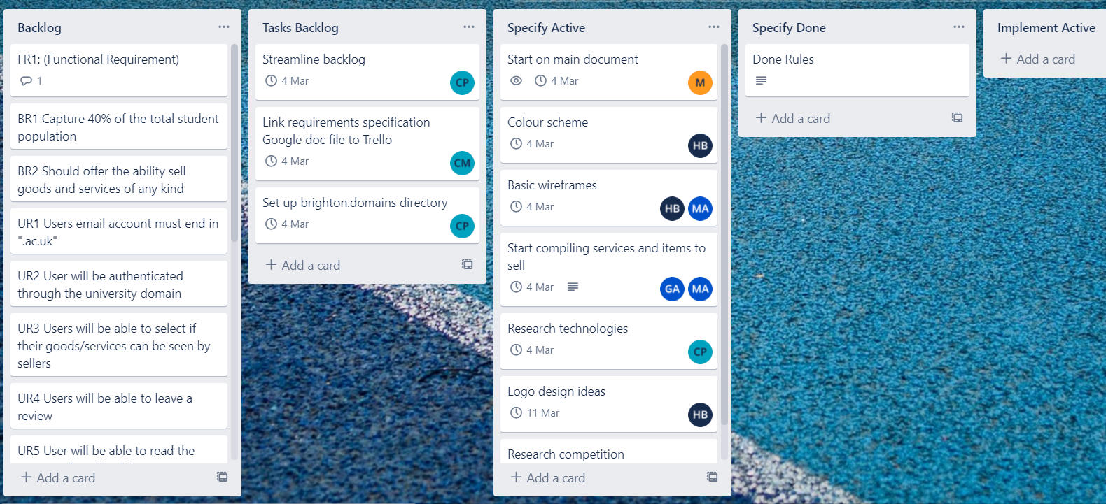

Above is our group Trello board. As we are still in early stages most of the tasks in the active section are research and simple design tasks. We have also elaborated on our requirements and are as follows:

| Requirement | Elaboration | Why it's important |
| --- | --- | --- |
| User logins and Registration | Website will only accept ‘ac.uk’ | Keeps the store students only |
| Landing/Home Page | Users can filter by category, price and recommended.  Suggestions will appear as the user types into the search bar.  If a specific item is not available, show similar products | Keeps our website in line with similar sites and makes it a much easier user experience. |
| Product/Service Page | Users can write a short description of their item or service to post  Prices will be listed  Users can click on images to enlarge them. | Helps guide users to the right product/service |

# 

# Week 4

